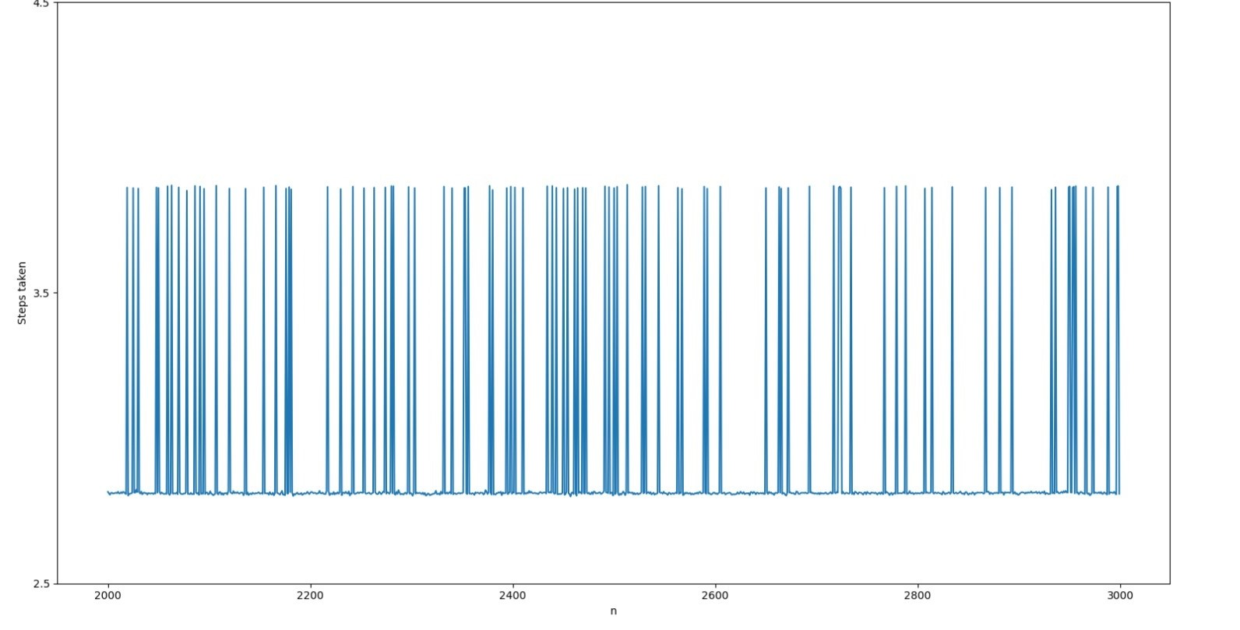 Test Case 4

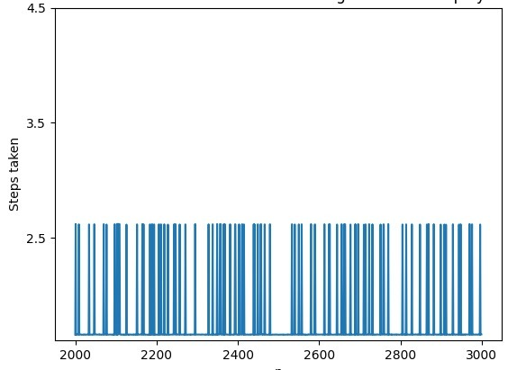 Test Case 3

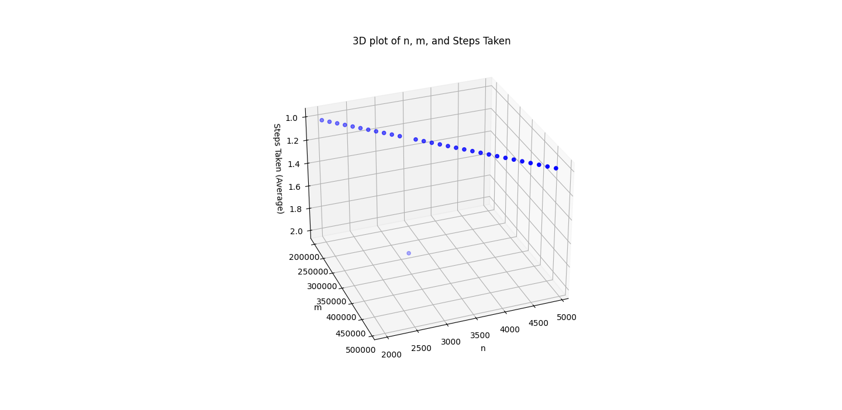

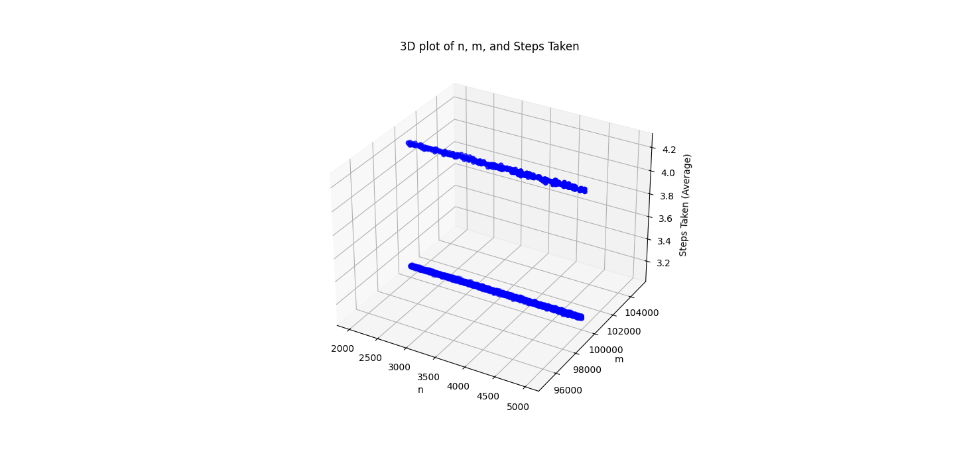

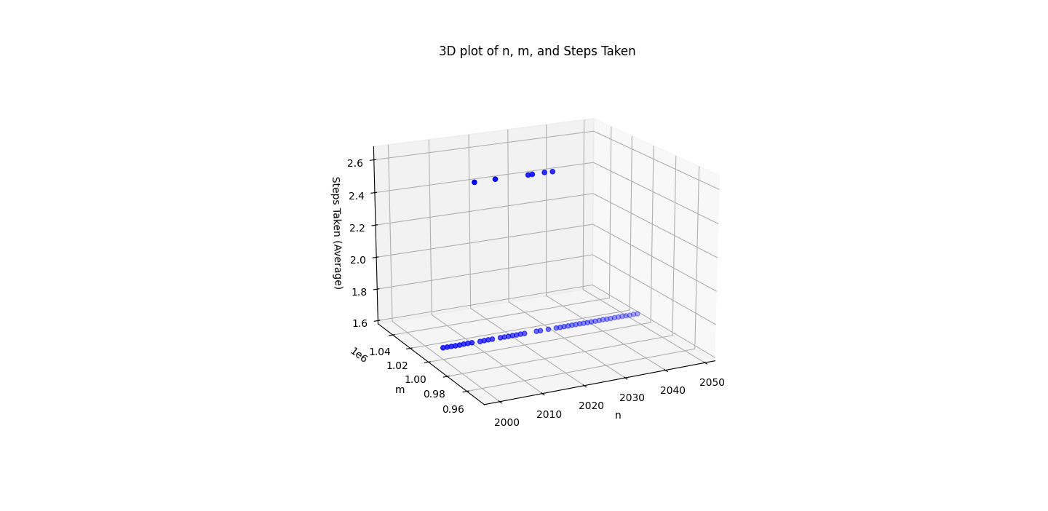

Test Case 1

Test Case 2

Test Case 6

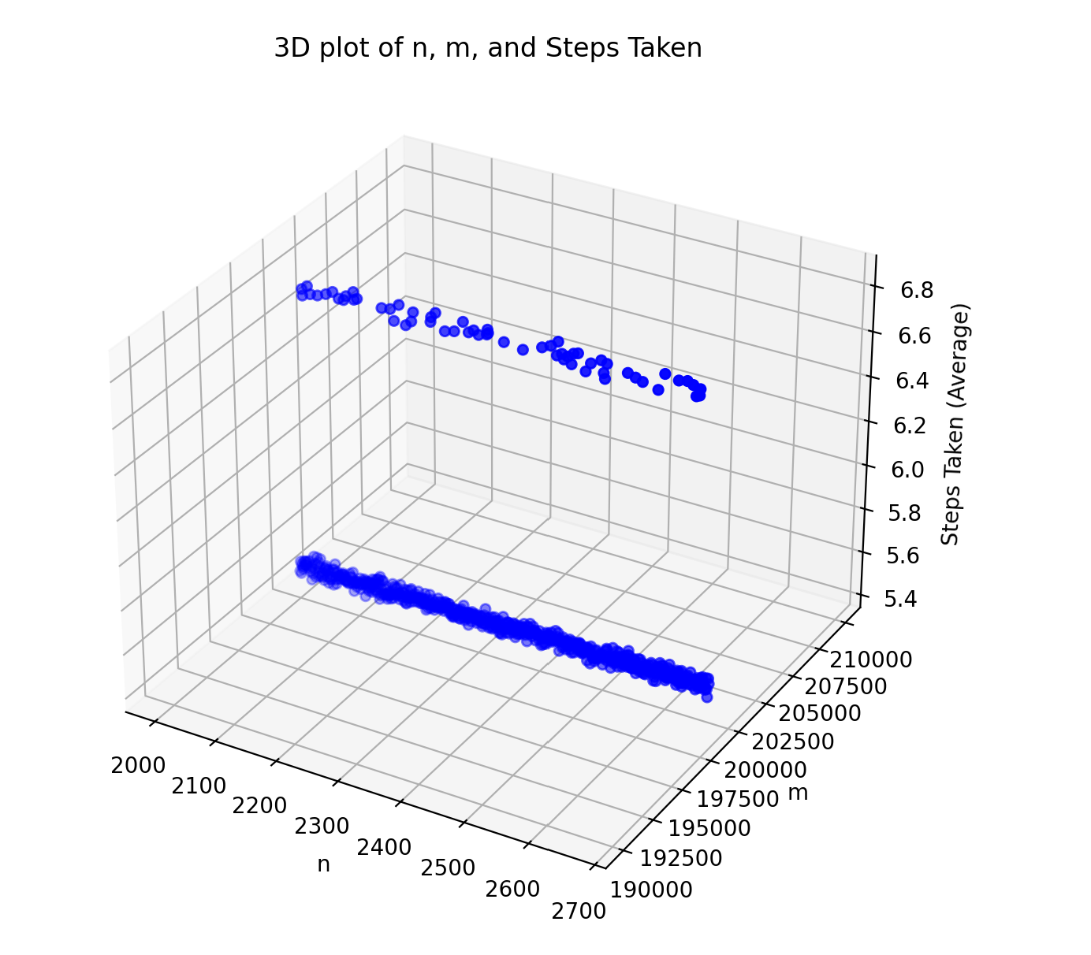 Test Case 7